Replacing IR-LED’s and Photo-Transistors in a Heathkit Weather Boom

Many times the IR-LED’s and/or Photo-Transistors can be damaged by lightning in the weather booms of the Heathkit ID-4001, ID-5001 and similar kits. We provide new replacement IR-LED’s and Photo-Transistors so you can repair your weather station and get it working again.

The old Texas Instruments parts that were used by Heathkit, are no longer available. The industry also has moved to a standard JEDEC package called a “T1” package. The old TI parts, did not conform to this specification and were a bit shorter than what is available today. The new parts will work but you must be careful to mount the parts correctly. Here are some tips to help out. Do not mix these new parts with older original parts. Replace the set.

When removing the old LED’s or Photo-Transistors, take care not to overheat the foil traces such that they lift up from the board. It’s better to cut out the parts from the top, then remove any remains of the leads with a soldering iron from the bottom. This uses less heat. If a trace is damaged, you can use a small piece of wire to run along the top of the trace to replace the actual trace.
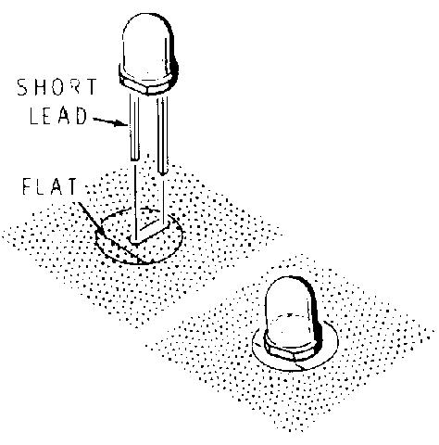
Check all of the traces on the board, sometimes if the weather housing has leaked, “acid rain” can cause the copper on the board to become pitted. If this is bad enough, the traces will be open and will not be conducting the signal.

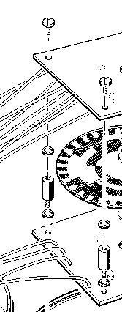
When mounting the new LED’s or Photo-Transistors, make certain that they are installed flush against the board. These new parts have a very narrow viewing angle and if they are not perpendicular to the board, the signal will be lower and it may not operate. Also note that the Photo-Transistors appear to have a smoke color to the packaging. This is an Infra-Red material that will reduce most ambient light and allow only the IR light to pass. This is normal. The LED’s do not have this tint and appear either yellowish or pinkish. With these new parts, you will not need to replace the rubber grommet as pictured in the manual.

Remember that these LED’s emit Infra-Red light and it is not visible to the naked eye. If you question whether or not the LED’s are working, you can always view them through a digital camera, or a video recorder. The sensors on these devices are able to see IR light and you will see that the LED is indeed emitting light.

After you have installed the LED’s and Photo-Transistors, you will re-assemble the two boards with the parts facing each other. Depending on tolerances of the metal spacers, the bearings, and the shaft, you may find that the plastic disk is dragging on the bottom parts. If this is the case, you can simply add an additional # 6 lock washer between the board and the spacer. This will be enough to stop the dragging of the disk against the bottom parts. This must be done on all four spacers to keep the boards parallel to each other. Important: Make sure the metal washer is mounted correctly against the plastic disk. If the plastic disk seems to wobble turn the metal washer over.

If you find that the plastic disk was already rubbing and has scratched off the black areas, you can simply fill them in with flat black model paint. Be sure to color the side that contains the black silkscreen.

Remember to test out the boom before installing it back on the roof.

If you have any questions, please send us an email to:

Don@D8aPro.com

